**Dharmsinh Desai University, Nadiad**

**Department of Information Technology**

**Advanced Java Technology, IT619**

**B.Tech. IT, Sem: VI**

**Experiment – 03**

**Submitted By**

**Roll No.:IT076**

**Name: DISHANT MODH**

**Aim:**  Create user registration functionality for student to get registered with exam- result

section. The registration page takes following information from user: user ID, password,

confirm password, full name, semester, roll no, email-id, and contact number. The

registration servlet checks uniqueness of user ID among all users and if found unique

then only stores registration information in database.

**Code:**

**🡪XML File: -**

<?xml version="1.0" encoding="UTF-8"?>

<web-app version="3.1" xmlns="http://xmlns.jcp.org/xml/ns/javaee" xmlns:xsi="http://www.w3.org/2001/XMLSchema-instance" xsi:schemaLocation="http://xmlns.jcp.org/xml/ns/javaee http://xmlns.jcp.org/xml/ns/javaee/web-app_3_1.xsd">

<servlet>

<servlet-name>Registration</servlet-name>

<servlet-class>Registration</servlet-class>

</servlet>

<servlet-mapping>

<servlet-name>Registration</servlet-name>

<url-pattern>/Registration</url-pattern>

</servlet-mapping>

<session-config>

<session-timeout>

30

</session-timeout>

</session-config>

</web-app>

**🡪JSP File: -**

<!DOCTYPE html>

<html>

<head>

<title>Exam Registration</title>

<meta http-equiv="Content-type" content="text/html; charset=UTF-8">

</head>

<body style="background-color:powderblue">

<center><h2>Registration</h2></center>

<form action="Registration">

<table>

<tr>

<td>USERID:</td>

<td><input type="text" name="uid"></td>

</tr>

<tr>

<td>PASSWORD:</td>

<td><input type="password" name="pass"></td>

</tr>

<tr>

<td>CONFORM PASSWORD:</td>

<td><input type="password" name="cpass"></td>

</tr>

<tr>

<td>FullName:</td>

<td><input type="text" name="fname"></td>

</tr>

<tr>

<td>SEMESTER:</td>

<td>

<input type="radio" name="sem" value="1"> 1

<input type="radio" name="sem" value="2"> 2

<input type="radio" name="sem" value="3"> 3

<input type="radio" name="sem" value="4"> 4

<input type="radio" name="sem" value="5"> 5

<input type="radio" name="sem" value="6"> 6

<input type="radio" name="sem" value="7"> 7

<input type="radio" name="sem" value="8"> 8<br>

</td>

</tr>

<tr>

<td>ROLLNO:</td>

<td><input type="text" name="rno"></td>

</tr>

<tr>

<td>EMAIL:</td>

<td><input type="text" name="email"></td>

</tr>

<tr>

<td>CONTACT NO:</td>

<td><input type="text" name="contact"></td>

</tr>

<tr>

<td><input type="submit" value = "REGISTER"></td>

</tr>

</table>

</form>

</body>

</html>

**🡪Registration Servlet: -**

import java.io.IOException;

import java.io.PrintWriter;

import javax.servlet.ServletException;

import javax.servlet.http.HttpServlet;

import javax.servlet.http.HttpServletRequest;

import javax.servlet.http.HttpServletResponse;

import java.sql.*;

public class Registration extends HttpServlet {

Connection cn = null;

ResultSet rs = null;

String driver = "org.apache.derby.jdbc.ClientDriver";

String url="jdbc:derby://localhost:1527/Registration";

String query = "insert into registration values (?,?,?,?,?,?,?,?)";

PreparedStatement pst = null;

protected void processRequest(HttpServletRequest request, HttpServletResponse response)

throws ServletException, IOException {

response.setContentType("text/html;charset=UTF-8");

PrintWriter out = response.getWriter();

try {

/* TODO output your page here. You may use following sample code. */

out.println("<!DOCTYPE html>");

out.println("<html>");

out.println("<head>");

out.println("<title>Registration</title>");

out.println("</head>");

out.println("<body style=\"background-color:powderblue\">");

try{

Class.forName(driver);

cn = DriverManager.getConnection(url,"dmx","dmx");

}

catch(Exception e){ }

int flag=0;

try{

pst = cn.prepareStatement(query);

PreparedStatement pst1=cn.prepareStatement("select * from Registration where userid = ?");

pst1.setString(1,request.getParameter("uid"));

ResultSet rs1=pst1.executeQuery();

if((request.getParameter("uid")=="") || (request.getParameter("pass")=="") || (request.getParameter("cpass")=="") ||(request.getParameter("fname")=="") || request.getParameter("sem")=="" || request.getParameter("rno")=="" || request.getParameter("email")=="" || request.getParameter("contact")=="")

{

out.println("Enter whole data!!!!!");

}

else if(rs1.next() == true)

{

out.println("<p>UserID Is Already Exist</p>");

out.println("<p>Please, Insert Correct Data: </p>");

}

else{

if(request.getParameter("pass").equals(request.getParameter("cpass")))

{

pst.setString(1,request.getParameter("uid"));

pst.setString(2,request.getParameter("pass"));

pst.setString(3,request.getParameter("cpass"));

pst.setString(4,request.getParameter("fname"));

pst.setInt(5,Integer.parseInt(request.getParameter("sem")));

pst.setInt(6,Integer.parseInt(request.getParameter("rno")));

pst.setString(7,request.getParameter("email"));

pst.setString(8,request.getParameter("contact"));

int ix=pst.executeUpdate();

out.println(ix+" records inserted");

cn.close();

flag=1;

}

else

{

out.println("<p> Conform Password doesn’t Matched</p>");

out.println("<p>Please, Insert Correct Data: </p>");

}

}

}

catch(Exception e){ }

if(flag == 1)

{

out.println("<p>Your Data Is Inserted Successfully</p>");

}

else{

out.println("<a href=\"index.jsp\">Back TO Registration</a>");

}

}

catch(Exception e){}

finally{

out.println("</body>");

out.println("</html>");

}

}

@Override

protected void doGet(HttpServletRequest request, HttpServletResponse response)

throws ServletException, IOException {

processRequest(request, response);

}

@Override

protected void doPost(HttpServletRequest request, HttpServletResponse response)

throws ServletException, IOException {

processRequest(request, response);

}

@Override

public String getServletInfo() {

return "Short description";

}

}

**Input/Output:**

1. **JSP Form Page: -**

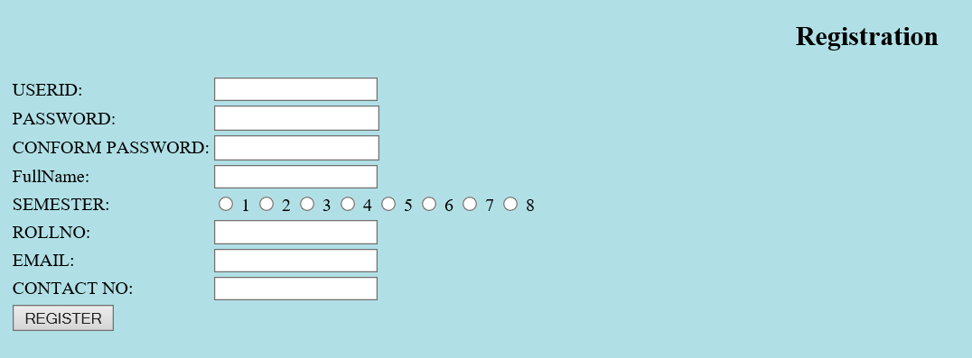

1. **When Data not entered:**

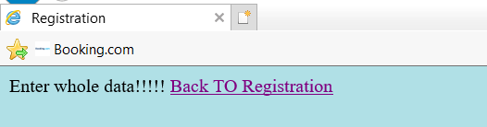

1. **When the Data is Inserted: -**

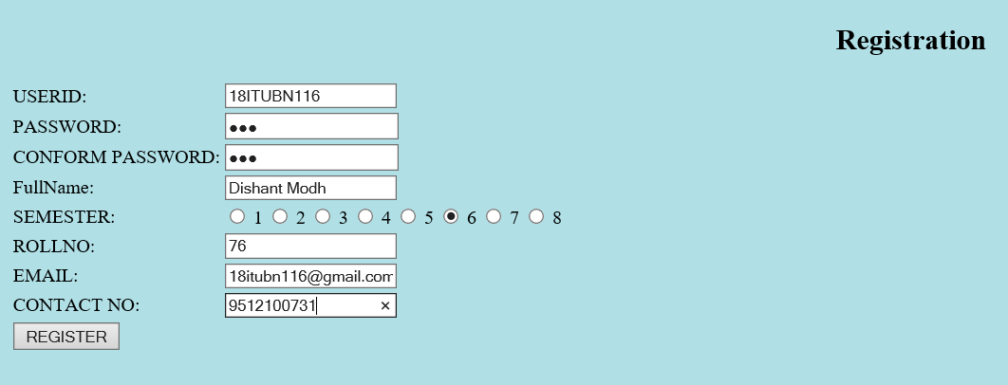

1. **After clicking on “Register”**

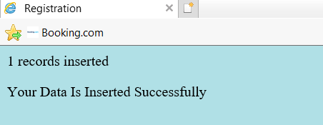

1. **When UserID already exists: -**

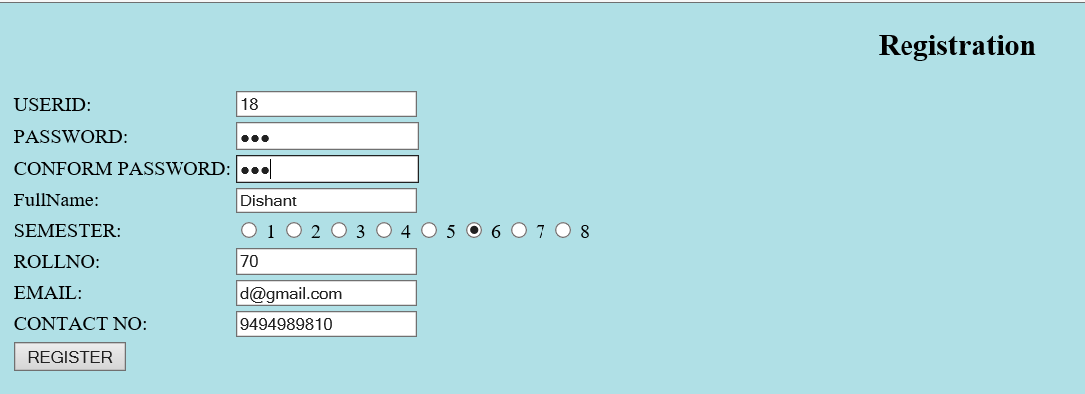

1. **An Error msg. will display: -**

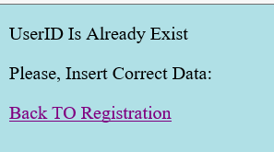

1. **When Password and Conform Password Doesn’t Match: -**

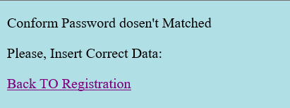

1. **Registration Database:**

